Exploratory Analysis of Rainfall Data in India for Agriculture
Project Documentation

1. Introduction
Project Title: Exploratory Analysis of Rainfall Data in India for Agriculture
Team Members: Manikanta Gedda (ML & Backend), Team Members (Frontend, Data Analysis)

2. Project Overview
Purpose: To analyze historical rainfall data in India using EDA and ML to assist farmers, policymakers, and experts.
Features: Rainfall prediction, data visualization, crop planning insights, web-based interface.

3. Architecture
Frontend: HTML, CSS for user input and results display.
Backend: Flask-based Python server handling requests and predictions.
Model Layer: Trained ML model with scaler and encoder.

System Architecture Diagram
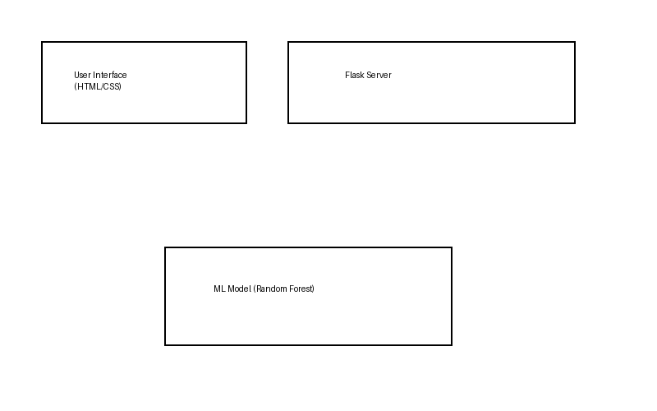

4. Setup Instructions
Prerequisites: Python 3.x, Flask, Pandas, NumPy, Scikit-learn, Anaconda.
Installation: Install dependencies using pip and run the Flask app.

5. Folder Structure
templates/: HTML files
static/: CSS & images
app.py: Flask backend
model.pkl: Trained model

6. Running the Application
Run: python app.py and open http://localhost:5000

7. API Documentation
POST /predict: Accepts weather inputs and returns rainfall prediction.

8. Authentication
Not implemented (future scope).

9. User Interface
The UI provides form inputs and displays rain/no-rain results with visuals.

10. Testing
Model evaluated using accuracy, confusion matrix, ROC-AUC.

11. Screenshots / Demo
Screenshots of UI and prediction results can be added here.

12. Known Issues
Model accuracy depends on data quality and completeness.

13. Future Enhancements
Cloud deployment, real-time weather API integration, multi-day forecast.

